Best Practice in Managing UK PharmaScan
Case Studies

Key Principles of Best Practice
While companies vary in the approaches they take to managing UK PharmaScan, there are five key principles for success:
- Assigning overall accountability for UK PharmaScan to one individual
- Including UK PharmaScan as an objective for all company personnel involved in data collation and entering and updating data
- Having clear roles and responsibilities
- Having set processes for data collection, collation, entry and updates and good communication and knowledge of these within the company
- Using an Excel proforma (detailing all UK PharmaScan fields) to collate data – click icon below for an example
Education on the importance of UK PharmaScan as an essential component of market access is also a key factor in getting people on board and ensuring understanding of the data requirements and the need to keep data accurate, comprehensive and up-to-date.


The Basics
- UK PharmaScan is the prime source of information for NHS horizon scanning bodies on new medicines, new indications / licence extensions and new formulations for existing medicines and in-licensed medicines developed by a third party, which are in phase III clinical development or three years from estimated UK launch. This should include biosimilars but not generic medicines.
- Information must be kept up-to-date: regulatory information should be updated IMMEDIATELY new information is available. All other information should be updated every THREE MONTHS.
- For those records that do not require any changes, click on ‘Mark as no change’.

Why?
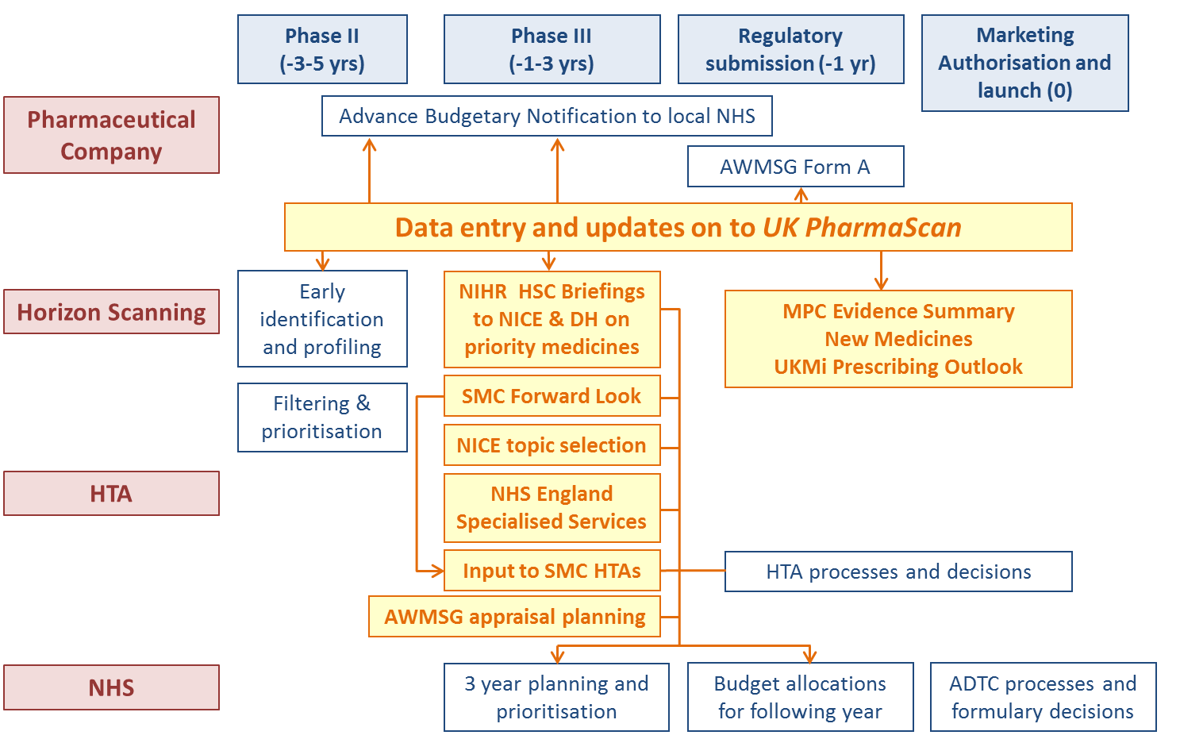
UK PharmaScan is used by all the UK’s horizon scanning bodies. As such it is a key part of company market access strategy.

Case Study 1 – Large Company

Accountability
- A Super User is allocated. This user has overall accountability for UK PharmScan and for ensuring all products are entered and the data are kept up to date.
- Therapy Area Leads have responsibility for collating, entering and updating data.
- UK PharmaScan is included in the objectives of the Super User and Therapy Area Leads.

Data collation and data entry / update process

Super User identifies new medicines to be entered on to UK PharmaScan

Data Collation
- Excel proforma circulated by the Therapy Area Lead to relevant company people for completion of specific information
- Completed proforma returned to the Super User for review and feedback

Data entry
- Data entered by Therapy Area Leads
- Super user checks data entered and submits record for QA

Data updates
- Initiated by the Super User who requests the Therapy Area Leads to update UK PharmaScan entries
- Existing proformas circulated by Therapy Area Leads to the relevant company personnel for updating – all updates highlighted
- Completed proforma (with updated information) returned to the Therapy Area Lead

Data entry
- Updated data entered by Therapy Area Leads
- Super User checks data entered against the completed proforma and submits record for QA

Case Study 2 – Large Company

Accountability
- The HTA Manager has overall accountability for UK PharmaScan
- Data entry for new products is completed by two UK teams: the New Product Planning team coordinate the initial entry of new technology records and hand over responsibility for data entry (and updates) to the HTA submission team around 18 months to two years prior to launch
- ‘Ensure UK PharmaScan is up to date’ is included in the objectives of the New Product Planning and HTA teams responsible for data entry and data updates

Data collation and data entry / update process

UK New Product Planning team is responsible for identifying new medicines, new formulations/new licence indications three years from UK launch or in Phase III clinical development

Data collation
- Data is collated using an Excel proforma. The UK New Product Planning Team or HTA Submission Team is responsible for completing UK specific fields while the relevant global product team completes other proforma fields

Data entry
- Performed by the UK New Product Planning Team. A PDF copy of the data entered is circulated to the global and UK team for review and approval

Data updates
- The UK New Product Planning Team or HTA Submission Team is responsible for updating records. A PDF of the updated record is circulated to the global and UK team for information

Case Study 3 – Large Company

Accountability
- A small team of two, including the UK PharmaScan lead / Project Manager, is responsible for ensuring the appropriate data is collated and entered

Data collation and data entry

UK PharmaScan lead / Project Manager is responsible for highlighting products for data entry

The decision as to when to collate data is based on when a product enters phase III clinical development and when there is enough information available to complete the mandatory fields.

Data collation
- A template is used to collate data.
- The relevant teams are contacted during the collation of data. Contacts are given two weeks to provide information
- All completed templates are checked and validated by Medical Affairs
- The completed templates are saved on an internal site. The Project Manager has control of these templates

Data entry
- The Project Manager is responsible for data entry

Data updates
- Updates are collated by means of tracked changes to the initial spreadsheet.
- The Project Manager is responsible for initiating the update request. This request is sent to the lead for each product team.

Data entry
- The Project Manager is responsible for data entry
Case Study 4 – Biotech Company

Accountability
- The database is “owned” by the Value Access and Policy (VAP) team within the UK and Ireland (UK/I) and supported by the commercial and Research and Development teams
- The UK Health Economics Manager is accountable for UK PharmaScan

Data collation and data entry

The UK Health Economics Manager is accountable for UK PharmaScan

Data collation
- A template is used to collate data. Each health economist in the UK/ VAP team is allocated a specific pipeline product
- Once collated the commercial R&D compliance team conducts a QA check
- Completed forms are returned to the Health Economics Manager

Data entry
- The Health Economics Manager is responsible for data entry

Data updates
- The Health Economics Manager is responsible for triggering the need for updates
- The initial templates are circulated to the relevant health economist(s) to check if any updates are required to the record.
- The updated templates are sent to commercial R&D compliance product managers for QC. Completed forms are returned to the Health Economics Manger for data entry

Data entry
- The Health Economics Manager is responsible for data entry

Case Study 5 – Small Company

Accountability
- One user has accountability for the database and acts as the Project Manager

Data collation and data entry

One user has accountability for UK PharmaScan and acts as the Project Manager

Data collation
- Initiated by the Project Manager
- Email requests and a key data spreadsheet are used to initiate dialogue
- The email request goes to the product lead, regulatory and EU lead

Data entry
- Following agreement to create an entry on UK PharmaScan:
  - The UK PharmaScan project manager liaises with the product lead with regards to the data to be entered – this allows complete buy-in, transparency and approval of wording
  - Product lead and the Project Manager decide if the data requires further approval or if it can be submitted for UK PharmaScan QA
  - Updates are performed on a regular basis following the same process
Data updates
- Updates follow the same process as outlined above

